Exercise #10
1.Display the sum of ages of employees working at BIgnet.
SELECT SUM(age) FROM employee_table;
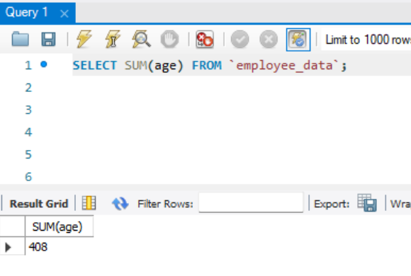
2. How would you calculate the total of years of service the employees of Bignet have in the company?
SELECT SUM(yos) FROM employee_data;
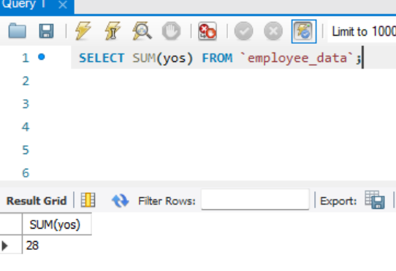

3. Calculatr the sum of salaries and the average age of employees who hold “Programmer” title.
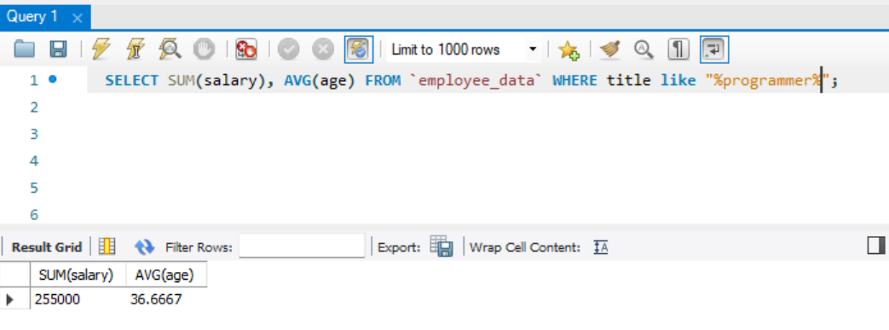
4. What do you understand from the following statement?
Select (SUM(perks) / Sum(salary) * 100) from employee_data;

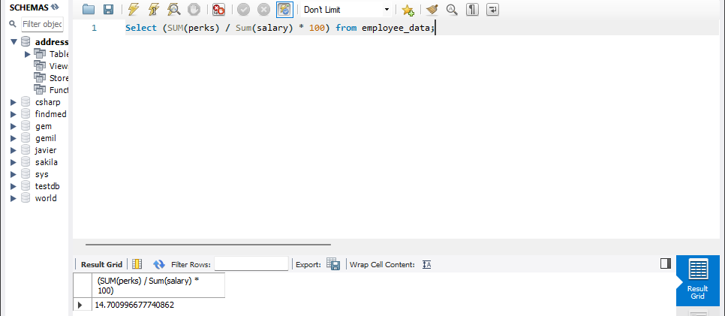
-- It gives the total perks as a percentage of the total salary related to all employees.

